SQL ASSINGMENT 1

Ques 1.) Creating sample tables and inserting values.

Create the following tables with the given structures and insert sample data as specified :-

A) SALESPEOPLE
Snum int(4)
Sname varchar(10)
City varchar(10)
Comm float(3,2)
**Creating table sales people :--

** Inserting given data :--

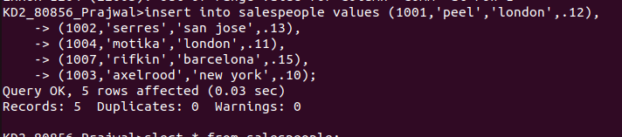

**Table Output :--

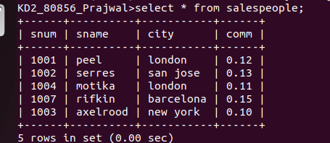

B) CUSTOMERS
Cnum int(4)
Cname varchar(10)
City varchar(10)
Rating int(4)
Snum int(4)

**Creating table customers :--

** Inserting the given data :--

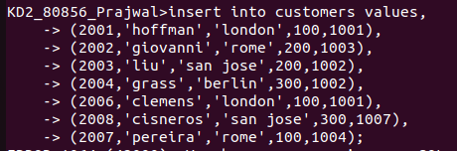

**Table output :--

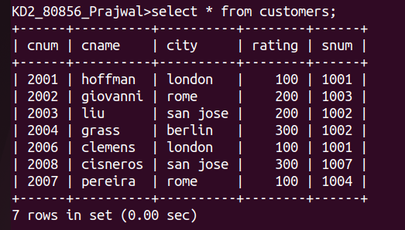
C) ORDERS
Onum int(4)
Amt float(7,2)
Odate date
Cnum int(4)
Snum int(4)

** Creating table orders :--

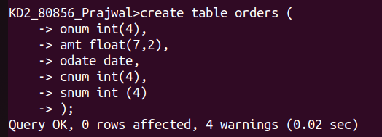

** Inserting the given data :--

** Table output :--

